 | The CAMECA IMS 7f-Auto  ion optics user’s guide (1)  The primary ion optics  00 45 627 957 – Type 108 – Indice A
0000.doc
Index
Contents

1. Introduction 2
1.1 The IMS 7f-Auto 2
1.2 Basic ion optics: lenses, deflectors, stigmators... 2
2. The primary column 3
2.1 Overview 3
2.2 Available parameters 4
2.3 The Wien filter 6
2.4 The primary column last stage 7
2.4.1 Overview 7
2.4.2 Rastering the primary beam and Monitoring the primary beam current 7
2.5 Primary beam impact angle and the landing issue 8
3. Tuning the primary ion column 11
3.1 Overview 11
3.2 Tuning using the Duoplasmatron source 12
3.2.1 Varying the primary current 12
3.2.2 Overall alignment procedure 15
3.3 Tuning using the Cesium source 18
3.3.1 Varying the primary current 18
3.3.2 Overall alignment procedure 19

Introduction

The IMS 7f-Auto
The Cameca IMS 7f-Auto is a magnetic sector SIMS instrument. The IMS-7f-Auto ion optics consists of:
- a primary column, equipped with 2 sources, presented in this volume, Primary column, ion optics user’s guide
- the secondary ion optics, presented in the second ion optics user's guide.

Additionally to the ion optics user's guide 2 volumes, all the IMS 7f-Auto and user's guide volumes are available from the Index.
The largest part of this document is targeted to give an expert user a deep understanding of the instrument.

Basic ion optics: lenses, deflectors, stigmators...
In ion optics, or more generally in charged particle optics, image transfer may be described with the same formalism as for conventional photon geometrical optics. The paraxial theory and the matrix method can be used in the same way for defining first order properties such as focal length for a lens or second or third order aberrations. The same terminology (ray, conjugated points, principal plane, spherical aberration, stigmatism etc...) is used for both ion optics and photon optics. It is therefore possible to read and to understand coarsely this ion optics user's guide (§ the primary column and § the secondary ion optics ) without special knowledge in matter of ion optics. For a more accurate understanding, it might be necessary to read the Basic ion optics user's manual which contains a short presentation of the ion optical devices (Lenses, Deflectors, Stigmators, ESA, Magnets...) implemented in the Cameca SIMS instruments.

The primary column

Overview
The IMS 7f-Auto is equipped with an in-line ion optical primary column, which consists of a set of electrostatic ion optical devices for focusing and deflecting the primary ion beam, aperture diaphragms, and a Faraday cup for accurate primary ion current measurement. A differential pumping stage ensures UHV sample environment during analysis. The primary column is fully computer controlled with motor driven apertures and automatic gate valves.
A source chamber allows simultaneous mounting of a high brightness (cold cathode) duoplasmatron source producing O₂⁺, O⁻, O₂⁻ ions, and of a high brightness (thermo-ionization) cesium microbeam source producing Cs⁺ ions.
The oxygen beam is particularly efficient for optimizing the sensitivity for electropositive element analysis, whereas the cesium beam enhances the sensitivity for electronegative element analysis.
The source chamber is equipped with a Wien mass filter to be used with the duoplasmatron source for removal of parasitic primary ion species. The chamber is isolated from the primary ion column with a gate valve, and receives its own turbomolecular pumping.
The duoplasmatron source is fixed and mounted at the top, in-line with the primary ion column. An accel-decel extraction system is fitted between the source and the Wien mass filter, which makes possible to run analyses with O₂⁺ primary ions at an impact energy as low as 500eV.
The cesium microbeam source is retractable; it moves between the parking chamber (when not used for analysis) and the working position, in-line with the primary column. Cesium source transfer between parking and working positions is fully computer controlled.
Both duoplasmatron source, and cesium parking chamber, are isolated from the source chamber with gate valves and receive their own turbomolecular pumping. Thus the maintenance of a given source can be performed while working with the other source. Switching source operation as well as the start-up and shut-down of the sources are fully computer controlled.
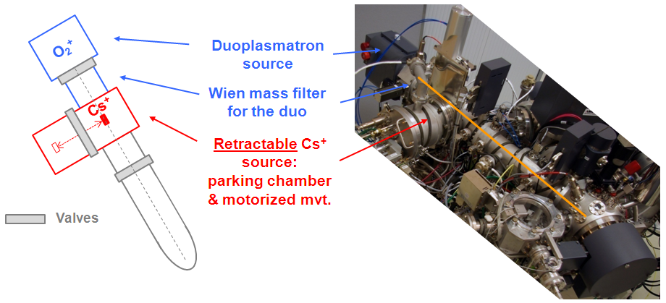

Available parameters
The extraction electrode of both sources is connected to the ground potential of the instrument, while the duoplasmatron and Cesium gun assembly (ionizer + reservoir) are brought at high voltage. According to the polarity, the positive or negative produced ions are accelerated. This optical system (extraction electrode + source assembly) forms a source cross-over with a diameter of about 500 μm and 50 μm for the duoplasmatron and Cs sources, respectively (see The Cameca ion source user’s guide). The image of this cross-over is focused on the sample surface thanks to different optical systems of the primary column: L1, WL, L2, L3 and L4 lenses associated to deflectors (DP X & Y) and apertures (D0 and D4).
As the diameter of the primary spot on the sample surface is variable from 1 to 200 μm, the reduction of the system should be adjustable between 0.4 and 500, using the L1, WL, L2 and L3 lenses. The lens L4 is used to focus the beam on the sample surface.
The primary column parameters are shown in the schematics below.
Contents ↑
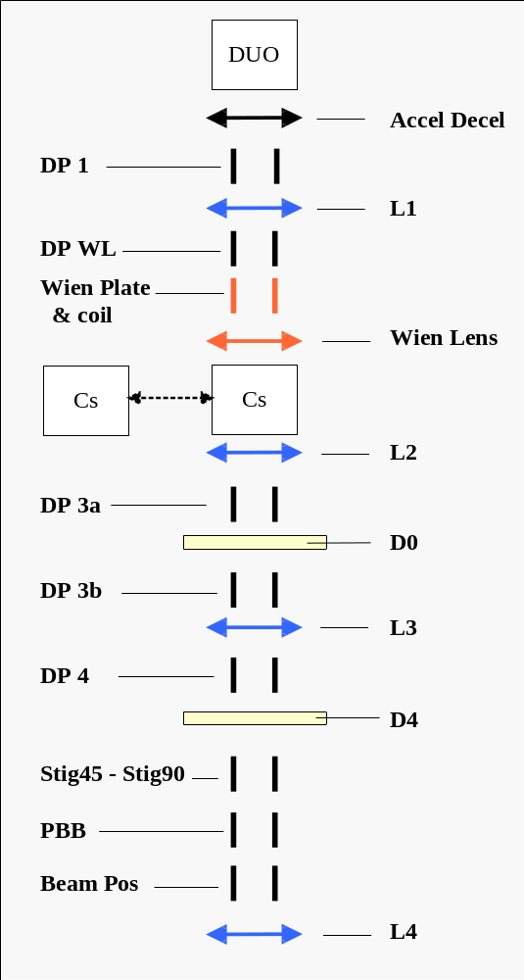
Contents 
Parameter | Tuning Labels | Functionality
Cs Source | CS HV  IONIZER  RESERVOIR | Cameca microbeam cesium source (refer to the ion source user'guide § The Microbeam Cs Source ) ,  ACCEL HV is the ionizer High Voltage with respect to the ground.  IONIZER is the electron current between the ionizer filament and the ionizer.  RESERVOIR is the electron current between the reservoir filament and the reservoir
Duo Source  Accel Decel | DUO HV  ARC CUR  COIL CUR  DUO ACL | Cameca Duoplasmatron source (refer to the ion source user'guide § The Duoplasmatron Source)  ACCEL HV is the source High Voltage with respect to the ground.  ARC is the plasma arc current.  COIL is the duoplasmatron coil current.  Accel Decel: Accelerating lenses for low energy primary beam
DP 1 | DP 1-X,  DP 1-Y | A 4-plate deflector used to center the beam within the L1 lens.
L1 | DuoL1 | An electrostatic lens that can be used, together with the L2 lens, for making an image of the source at the D0 aperture (Duo Source only).
DP WL  Wien filter  WL | DP WL-X,  DP WL-Y  WIEN COIL  WIEN DY  WIEN LENS | A 4-plate deflector used to center the beam within the Wien lens.  A Mass Filter consisting of 2 deflection electrostatic plates (WIEN DY) and a coil (WIEN COIL).  An electrostatic lens that can be used for making an approximate image of the source at the D0 aperture (Duo Source only). In practice, this lens is not used, as it is advised to use a combination of L1 and L2 lenses instead.
L2 | L2 | An electrostatic lens that can be used for making an image of the source at the D0 aperture (if the Duo Source is used).
DP 3a | DP 3a-X,  DP 3a-Y | A 4-plate deflector used to center the beam within the D0 aperture.
Aperture D0 | D0-X  D0-Y | Set of 6 apertures of different diameters (750µm, 650µm, 400µm, 300µm, 200µm, 100µm). When using the duo source, an image of the source is formed at D0 aperture.
DP 3b | DP 3b-X,  DP 3b-Y | A 4-plate deflector used to center the beam within the L3 lens.  .
L3 | L3 | An electrostatic lens purposed for varying the primary current reaching the sample surface.
Aperture D4 | D4-X  D4-Y | Set of 6 apertures of different diameters (750µm, 650µm, 400µm, 300µm, 200µm, 100µm) purposed for limiting the ion beam angle aperture.
DP 4 | DP 4-X  DP 4-Y  STIG 45  STIG 90 | An octopole with a set of implemented functions:  - Deflection (DP 4) used to center the beam within the L4 lens.  - Astigmatism correction functions, respectively in XY (STIG 90) and at 45° (STIG 45)
Primary Faraday Cup | DEF FC  FCP REP  GATE Y | Deflection (DEF FC) used to center the beam within the Primary Faraday Cup  The repeller (FCP REP) is a plate, perpendicular to the beam axis, located just upstream the Primary Faraday Cup and purposed for repelling the secondary electrons.  GATE Y parameter corresponds to the sampling rate (recommended value of 461 digits)
DPRIM5 | Beam Pos-X  Beam Pos-Y  Raster  D5 S1  Rot Y | A 4 plate deflector with a set of implemented functions:  - Primary beam X&Y position (Beam Pos)  - Primary beam rastering system (Raster)  - XY stigmator (D5 S1)  - Raster rotation (Rot Y)
L4 | L4 | Last lens used for achieving the primary spot focusing.

Contents ↑

The Wien filter
The Wien filter is used as a mass filter to eliminate spurious elements which can be generated in the ion sources, for example, Ni in the case of the Duo source. These species must be eliminated if it is considered as a contaminant with respect of the species of interest in the sample.
When using the duoplasmatron with oxygen the major species extracted from the source is the polyatomic ion ¹⁶O₂⁺, but for instance NO⁺ and ¹⁶O⁺ also exist, with an abundance of 1 or 2 decades below ¹⁶O₂⁺. Therefore, it is necessary to eliminate NO⁺ and ¹⁶O⁺ if a fine spot is required since both ¹⁶O₂⁻, and other species spots are not focused exactly at the same location because of earth or spurious magnetic fields.
Contents ↑

The primary column last stage

Overview
Primary Column last stage

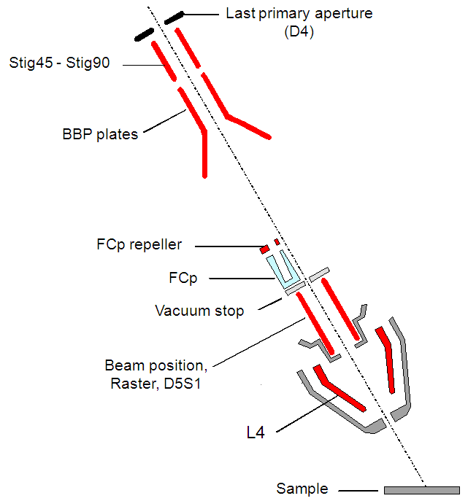

Rastering the primary beam and Monitoring the primary beam current
The ion primary beam can be rastered within the sample plane in order to achieve a scanning ion image or to record a depth profile with a flat bottom crater (See in the secondary ion optics user's guide the section § the depth profiling issue). A sequencer generates continuously Raster X&Y saw teeth which are applied onto the DPRIM5 plates when the Raster/Static selection is set to Raster. The 80 ms frame consists of 1024 lines rastered along the X-axis.
BBP (Primary Beam Blanking): A pair of deflection plates purposed for blanking the beam into the FCp primary Faraday cup, either in a continuous mode or in a sampling mode.
Monitoring continuously the primary current is achieved in a sampling mode: within every frame, a given percentage of the lines is dedicated to the current measurement. In the hereafter figure, this percentage is 2%. During 10 lines at the beginning and 10 lines at the end of the frame, the beam is blanked off the axis, into the primary Faraday cup. As a fast response is not required, the Faraday current is measured with a low bandwith and multiplied by the inverse of the sampling percentage for giving back the actual primary current. The unavoidable counterpart of this measurement is that the primary beam is not working during the 2% measurement time.
Practically, the recommended sampling rate is 10%. It corresponds to GATE Y = 461.

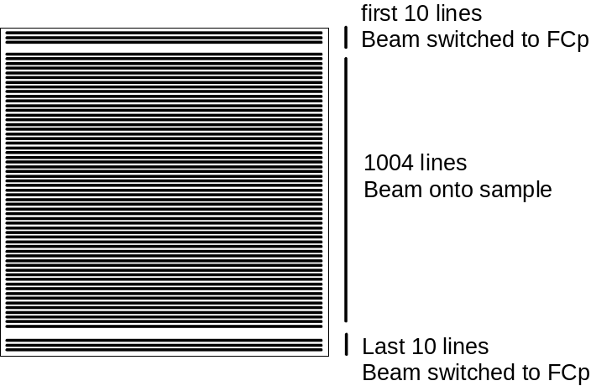
Contents ↑

Primary beam impact angle and the landing issue
All the space located between the source and the extraction electrode is at the ground potential except the space located between the extraction electrode and the sample plane. This space is an accelerating region for the secondary ions, while, for the primary ions, it is a decelerating space if both the primary and secondary voltage have the same polarity and it is an accelerating space if they have opposite polarities. As the primary axis is not normal to the sample plane, the primary trajectory is curved in this region, and it would not impinge the sample plane onto the secondary axis if there was not a compensating deflection depending on the decelerating or accelerating field.

This compensating deflection is achieved with the deflector DPRIM4-X (also labelled as Beam Pos-X). The center of this deflection is located at the last lens plane. The next figure, standing for positive primary ions (+10 kV), displays both cases:  - Sample HV=9 kV : The final space is decelerating.  - Sample HV=-9 kV: The final space is accelerating  In both cases, a deflection must be applied before the last lens (LPRIM4) in order to force the primary trajectory to impinge the sample plane onto the secondary axis. | 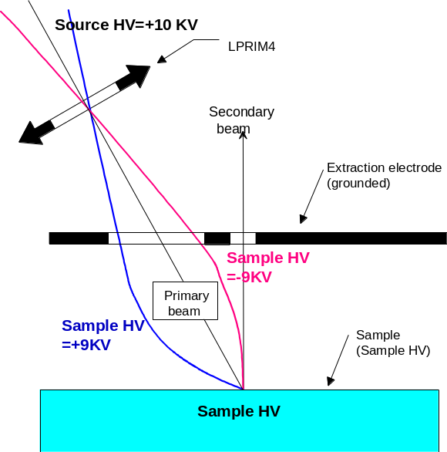
The primary beam impact angle can be computed, in first approximation, from the relationship
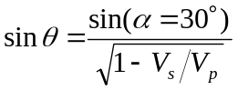
Where V_{s} and V_{p} stand respectively for the secondary and the primary acceleration voltage.
It must be noticed that the primary column DPRIM4 double deflector used to bring the primary spot back to the secondary axis, makes the primary beam entering the secondary ion extraction space with an angle α' different from the primary axis angle α=30° (refer to the next figure). A more accurate computation of the impact angle values can be performed by taking into account this effect. θ and θ' for different V_{s} and V_{p} are reported in the hereunder table
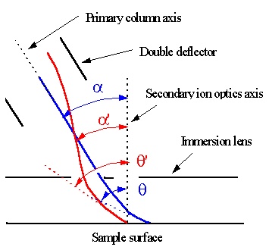 | 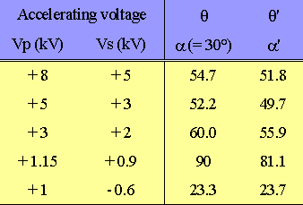
The diagram plotted in the hereunder figure displays the dependance of θ' on the primary acceleration voltage V_{p} for different secondary extraction voltage V_{s}.

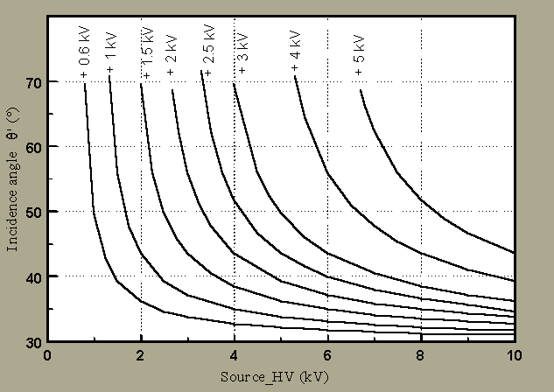

Examples of primary and secondary acceleration voltages suited to adjust the impact angle for impact energies of 2 kev, 1 keV and 0.5keV. | 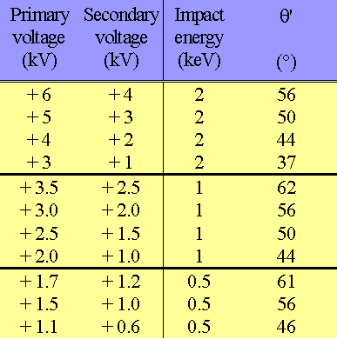

Contents ↑

Tuning the primary ion column

Overview
The primary preset pad
In the Tuning software guide, it is explained that for the same MAP (Main Analytical Parameters), several presets can be recorded, corresponding to primary probes of different sizes and different ion current intensities. Up to 9 different primary presets can be saved in the same ISF (Instrument Status File). One given preset can be recalled by clicking the corresponding button on the primary preset pad. Each of these presets consists of a set of the following parameters:
- DP 1 deflector (x & y)
- L1 lens (for the DUO only)
- DP wl deflector (x & y)
- WL lens (for the DUO only)
- L2 lens
- DP 3a deflector (x & y)
- DP 3b deflector (x & y)
- L3 lens
- DP 4 deflector (x & y)
- Stig45 and Stig90 stigmators
- Beam Pos deflector (x & y)
- D5 s1 stigmator
- L4 lens
- D0 aperture preset
- D4 aperture preset
The other parameters (Wien Coil, Wien DY, Def FC, Gate Y) are identical for all presets of the same ISF file.

Note that the primary preset includes the D0 and D4 aperture presets. The indication of D0 and D4 is given below the preset pad (see below). Thus, when clicking on a preset, the apertures will move to the corresponding positions. This function can be disabled through the D0, D4 Moving menu in the primary preset dialog box (for maintenance purposes). However, it is strongly recommended to keep this option enabled (movement of the apertures when clicking on the preset) during current use of the instrument.

1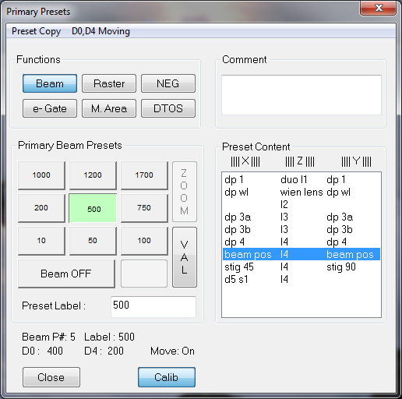

Contents ↑

Tuning using the Duoplasmatron source
The primary column tuning is described below for Duoplasmatron O₂⁺ source, positive secondary polarity, for the reference ISF file: Source HV = +15kV, sample HV = +5kV, corresponding to the highest impact energy (10keV).
It is advised to create the lower impact energy ISF files by performing an extrapolation from the high impact energy reference ISF file (using the Source HV valid and Sample HV valid functions of the Tuning program). The same tuning procedure, as described below, can then be applied for a more precise alignment. Note that the lenses and deflector values are expected to be proportional to the Source HV (except for L4, Beam Pos, and stigmators that also depend on the Sample HV, and the Wien DY parameter which varies as the square root of Source HV).
Contents ↑

Varying the primary current
It is advised to use different primary settings (L1, WL, and L2 lenses), for covering different primary current ranges, as shown in the table below:

O₂⁺ primary ions, Source HV = +15kV:
Range | Standard | Low
Ip | 1.5µA → 5nA | below 5nA
L1 | 2200 | 0
WL | 0 | 0
L2 | 1950 | 1950

The Standard conditions apply for primary current values above 5 nA, the Low conditions for primary current below 5 nA. For lower Source HV conditions, the lens values and primary current are expected to decrease proportionally to the Source HV.
Within a given range, the primary current can be varied through:
- Aperture selection: a smaller D0 aperture reduces both the current and beam size. A smaller D4 aperture reduces mostly current, but not significantly the beam size. Therefore, it is advised to use mostly the D0 aperture for changing the current.
- Lens L3:
  - Low values (usual conditions): for L3 values ranging between 0 and 50% of the source HV, the primary current (but also the beam size) increases with L3. Note: L3 should not exceed 50% of the source HV, and should be kept preferably below 40% of the source HV in order to keep a well focused primary beam.
  - High values (to be used only when very small spot diameter is required): for L3 values above a given threshold, the primary current (but also the beam size) decreases with L3.
In general, the following rules apply for changing the primary current:
- For decreasing the primary current, do by order until obtaining the requested primary current: decrease first L3 (if L3 is not set to 0), then decrease D0 and finally decrease D4.
- For increasing the primary current: do by order until obtaining the requested primary current: increase D4 (if D4 is smaller than 750µm), increase then D0 (if D0 is smaller than 750µm), and finally increase L3 (by keeping L3< 40% of the source HV).
Note that changing the aperture selection changes the primary current by discrete steps, while the L3 lens provides a continuous variation. Therefore, the aperture selection and L3 value may need to be combined if a precise primary current value is requested.
For very small beam (beam diameter < few µms), the following conditions must be selected: high source HV (typically ≥ 10kV), Low conditions, small D0 (typically 100µm) and D4 (typically 300µm down to 100µm), combined with high L3 value (typically above 70% of the source HV). The primary current (and beam diameter) is reduced using increasing values of L3.
The table below shows typical settings for different values of primary current for O₂⁺ primary ions, Source HV = 15 kV conditions. This table covers the whole range of primary current, and gives the corresponding beam spot diameter (measured value) for each condition. Figures 1-4 show the schematics of the ion beam trajectory for the different configurations.
O₂⁺ primary ions, Source HV = +15kV:
Range | Standard |  |  |  | Low
Ip (nA) | 820 | 330 | 110 | 23 | 5 | 1.8 | 0.8 | <0.5
D0 aperture | 750 | 750 | 650 | 200 | 200 | 100 | 100 | 100
D4 aperture | 750 | 750 | 750 | 750 | 750 | 500 | 300 | 300
L1 | 2200 | 2200 | 2200 | 2200 | 0 | 0 | 0 | 0
WL | 0 | 0 | 0 | 0 | 0 | 0 | 0 | 0
L2 | 1950 | 1950 | 1950 | 1950 | 1950 | 1950 | 1950 | 1950
L3 | 1660 | 0 | 0 | 0 | 0 | 0 | 0 | >2500
beam ∅ (µm) | ~28 | ~15 | ~12 | ~8 | ~7 | ~5 | ~4 | <4

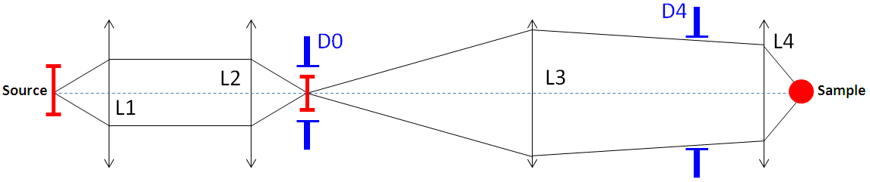
Figure 1: Schematics of the primary ion beam trajectory (Duo source) using Standard conditions (L1, L2) + lens L3: highest beam current.

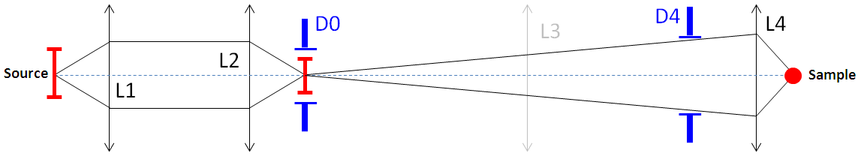
Figure 2: Schematics of the primary ion beam trajectory (Duo source) using Standard conditions (L1, L2) and L3=0: medium-high beam current.

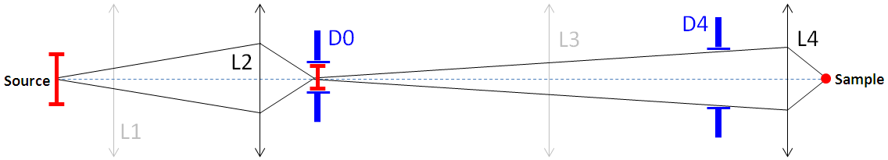
Figure 3: Schematics of the primary ion beam trajectory (Duo source) using Low conditions (L2) and L3=0: low beam current.
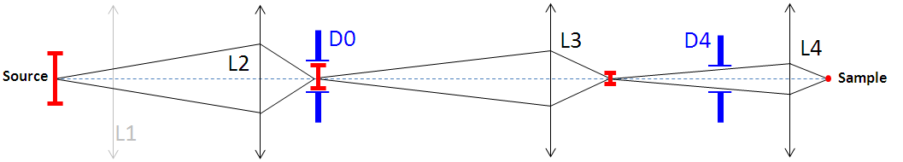
Figure 4: Schematics of the primary ion beam trajectory (Duo source) using Low conditions (L2) + high L3 values: small spot conditions.

Overall alignment procedure

The goal of this alignment is to set up the aperture positions and deflector values for each range of primary current: Standard and Low (see above).

Starting conditions:
Secondary ion parameters:
It is assumed that the secondary optics was aligned previously so that it is possible to display a focused secondary sample image on the MCP (Micro Channel Plate).
- Image mode, Transfer lens: 250 µm, FA #1 (1800µm) make sure to set DTFA X&Y to 0, CA#2 (150 µm) centered for a rather good quality of the image. Adjust fine controls of the immersion (lens, stigmators) and transfer lenses to get the best image.
Primary ion parameters:
- D0=D4=3000 (no apertures)
- All lenses and deflectors to 0, except for L4, Beam Pos, Def FC, which should be close to the typical values:
- Def FC ~ 200V (close to maximum value) for Source HV = 15kV
- L4 ~ 45000 digits and Beam Pos X ~ -900 digits for Source HV = 15kV, sample HV = 5kV
- Small Raster = 100 µm and DTOS On (check that DTOS is correctly calibrated by comparing with Raster Off).

Procedure:
- Primary current maximization without apertures (D0=D4=3000)
- Apply the starting conditions described above, if not yet done.
Important note: in order to have a correct reading of the primary current (Ip), as there is no D4 aperture, it is mandatory to focus the primary current in the primary FC using the L3 lens.
- Set L3 to 1660 digits (for Source HV=15 kV) for a correct reading of the primary current. This can be checked by scanning Ip vs. Def FC parameter using the Scan all program; a plateau near 200 V means that the Ip value displayed in the Real Time Screen bargraph is correct.
- With beam Off, maximize the Ip current by adjusting:
  - Duo Z electrode positionf
  - Duo gas pressure
  - Wien dY parameter (for cancelling a possible residual magnetism caused by the Wien filter, typically -30 digits)
Note: for Source HV = 15kV, a primary current of >100 nA should be obtained at this stage.
- Set L3 back to 0.
- Centering in L4 without apertures (D0=D4=3000)
- Verify that L3 is set to 0. With beam On, bring the primary beam to the center of the FA using Beam Pos X & Y, and focus the beam at best using L4 and stigmators.
- With Beam On, adjust DP 4 X & Y deflectors to center the beam while wobbling L4. The values of DP 4 deflectors should be close to zero. If an important Y displacement of the beam is observed, adjust first the height of the primary column.
- Adjusting the position of the D4 apertures
- Set D4=750µm. Verify that L3 is set to 0, and D0=3000.
- With Beam On, adjust D4 X & Y aperture position to center the beam while wobbling L4. Valid the D4 aperture preset.
Note: for Source HV = 15kV, a primary current of ~15 nA should be obtained at this stage.
- Repeat the same for all D4 apertures.
- Set D4 back to 750µm.
Note: the D4 X position is usually similar for all diaphragms (low value typically < 1000 digits). Each aperture has a different D4 Y position. Consecutive diaphragms have a difference in the Y position of ~3600 digits.
- Adjusting the position of the D0 apertures
- Set D0=750µm, while keeping D4=750µm.
- With Beam off, adjust D0 X & Y aperture position to maximize the primary current. Valid the D0 aperture preset.
- Repeat the same for all D0 apertures.
- Set D0 back to 750µm.
Note: the D0 X position is usually similar for all diaphragms (low value typically < 1000 digits). Each aperture has a different D0 Y position. Consecutive diaphragms have a difference in the Y position of ~3600 digits.
- Maximizing the transmission through the D0 aperture
- Set D4=3000µm (no aperture) and set D0=400µm.
- Set L3 to ~1660 digits (for Source HV=15 kV) for a correct reading of the primary current. Adjust Dp3a x & y and Dp4 x & y to center the beam while wobbling L4.
- Set L1, WL, L2 lens values to the tabulated values for Standard primary conditions (L1~2200, WL=0, L2~1950 digits for Source HV=15 kV).
- With Beam Off, maximize the primary current with DP 1 X & Y, and DP wl X & Y, and save a corresponding primary preset in the Tuning program.
Note: for Standard primary conditions at Source HV=15 kV (L1~2200, WL=0, L2 ~1950 dig.), D0=750µm, L3~1660 dig., D4=3000 (no aperture), a primary current of ~1.5 µA should be obtained.
- Repeat step E) for the Low primary conditions (L1=0, WL=0, L2~1950 digits for Source HV=15 kV, see below), and save a corresponding primary preset.
Note: for Low primary conditions at Source HV=15 kV (L1=0, WL=0, L2~1950 digits), D0=750µm, L3~1660 dig., D4=3000 (no aperture), a primary current of ~150 nA should be obtained.
- Centering the beam between D0 and D4 apertures
- Select the Standard primary preset.
- Set D4=750µm, and L3 back to 0.
- With Beam off, adjust DP 3a X & Y deflectors to maximize the primary current.
- With Beam On, bring the primary beam to the center of the FA using Beam Pos X & Y, and focus the beam using L4 and stigmators.
- With Beam On, adjust DP 4 X & Y deflectors (and not the aperture position) to center the beam while wobbling L4. Save the primary preset.
Note: for Standard primary conditions at Source HV=15 kV (L1~2200, WL=0, L2~1950 dig.), D0=750µm, D4=750µm, and L3=0, a primary current of ~300 nA should be obtained.
- Repeat step F) for the Low primary conditions (L1=0, WL=0, L2~1950 digits for Source HV=15 kV).
Note: for Low primary conditions at Source HV=15 kV (L1=0, WL=0, L2~1950 digits), D0=750µm, D4=750µm, and L3=0, a primary current of ~22 nA should be obtained.
- Using the Wien filter
- For using the Wien filter (e.g. metal analysis), set Wien coil to a 2 Amp (2000 digits), and recover the primary current using Wien Dy (typically ~ -200 digits).
- Using the accel-decel electrode
- For lower impact impact energy conditions, the accel-decel electrode (Duo ACL parameter) must be used in order to increase the primary current.

After this alignment, the aperture positions and deflector values are fixed for each range of primary current, Standard and Low, and should no longer be modified.
Contents ↑

Tuning using the Cesium source
The primary column tuning is described below for Cesium Cs⁺ source, negative secondary polarity, for the reference ISF file: Source HV = +10kV, sample HV = -5kV, corresponding to the highest impact energy (15keV).
It is advised to create the lower impact energy ISF files by performing an extrapolation from the high impact energy reference ISF file (using the Source HV valid and Sample HV valid functions of the Tuning program). The same tuning procedure, as described below, can then be applied for a more precise alignment. Note that the lenses and deflector values are expected to be proportional to the Source HV (except for L4, Beam Pos, and stigmators that also depend on the Sample HV).
Contents ↑

Varying the primary current
Note that when using the Cs⁺ source, only the L2, L3 and L4 lenses are used. It is advised to keep L2 fixed to 1960 digits (for Source HV = +10kV) in order to cover the whole primary current range. For lower Source HV conditions, the L2 value decreases proportionally to the Source HV.
Three different primary configurations (High, Medium, Low) can be defined depending on the D4 aperture selection (the primary current is reduced when using smaller D4 apertures). It is advised to keep D0=3000 (no aperture), unless a very small spot is required. This prevents the D0 aperture from being rapidly enlarged under Cs bombardment. The different configurations are shown in the table below.
Cs⁺ primary ions, Source HV = +10kV:
Range | High | Medium | Low
Ip | 500nA → 50nA | 50nA → 5nA | below 5nA
L2 | 1960 | 1960 | 1960
D0 | 3000 | 3000 | 3000
D4 | 750 | 200 | 100

Within each range, the primary current is continuously varied using lens L3. The values of L3 are higher than 1600 digits; for this range, the primary current decreases with increasing value of L3.
For very small beam (beam diameter < few µms), the following conditions must be selected: high source HV (typically 10kV), Low conditions, small D0 (typically 400µm) and D4 (typically 100µm), combined with high L3 value (typically above 70% of the source HV). The primary current (and beam diameter) is reduced using increasing values of L3.
The table below shows typical settings for different values of primary current for Cs⁺ primary ions, Source HV = +10 kV conditions.

Cs⁺ primary ions, Source HV = +10kV,
Reservoir current = 0.14mA, Ionizer current = 1.8mA
Range | High |  |  |  | Medium |  |  | Low
Ip (nA) | 550 | 250 | 100 | 50 | 40 | 22 | 7 | 4 | 2 | 0.5
D0 aperture | 3000 | 3000 | 3000 | 3000 | 3000 | 3000 | 3000 | 3000 | 3000 | 3000
D4 aperture | 750 | 750 | 750 | 750 | 200 | 200 | 200 | 100 | 100 | 100
L2 | 1960 | 1960 | 1960 | 1960 | 1960 | 1960 | 1960 | 1960 | 1960 | 1960
L3 | 1667 | 1902 | 2113 | 2274 | 1902 | 2020 | 2274 | 2113 | 2274 | 2514

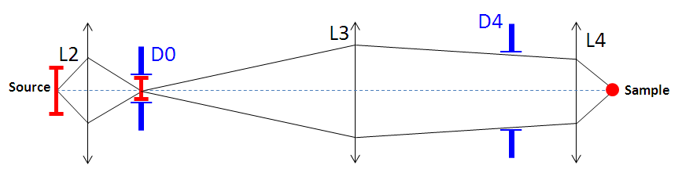

Figure 5: Schematics of the primary ion beam trajectory (Cs source): high beam current.

Contents ↑

Overall alignment procedure

The goal of this alignment is to set up the aperture positions and deflector values, that are common to the three configurations (High, Medium, Low).

Starting conditions:
Secondary ion parameters:
It is assumed that the secondary optics was aligned previously so that it is possible to display a focused secondary sample image on the MCP (Micro Channel Plate).
- Image mode, Transfer lens: 250 µm, FA #1 (1800µm), CA#2 (150 µm) centered for a rather good quality of the image. Adjust fine controls of the immersion (lens, stigmators) and transfer lenses to get the best image.
Primary ion parameters:
- D0=D4=3000 (no apertures)
- All lenses and deflectors to 0, except for L4, Beam Pos, Def FC, which should be close to the typical values:
- Def FC ~ 170V for Source HV = 10kV
- L4 ~ 31000 digits and Beam Pos X ~ 400 digits for Source HV = 10kV, sample HV = -5kV
- Small Raster = 100 µm and DTOS On (check that DTOS is correctly calibrated by comparing with Raster Off).

Procedure:
- Primary current maximization without apertures (D0=D4=3000)
- Apply the starting conditions described above, if not yet done.
Important note: in order to have a correct reading of the primary current (Ip), as there is no D4 aperture, it is mandatory to focus the primary current in the primary FC using the L3 lens.
- Set L3 to 1100 digits (for Source HV=10 kV) for a correct reading of the primary current. This can be checked by scanning Ip vs. Def FC parameter using the Scan all program; a plateau means that the Ip value displayed in the Real Time Screen bargraph is correct.
- With beam Off, maximize the Ip current by adjusting:
  - Cs source position along X. Use the Cs Source Position Calibration function of the Setup menu in the Tuning program. Set the steps range (typically 5) and shift the source position using the arrow buttons until obtaining the maximum current.
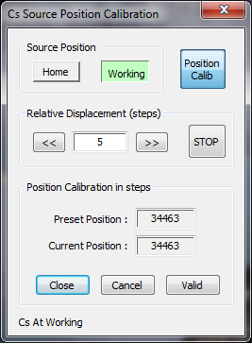
Step range selection
Cesium new position validation
  - Cs source position along Y. The Y axes of the source are adjusted manually (see picture below).

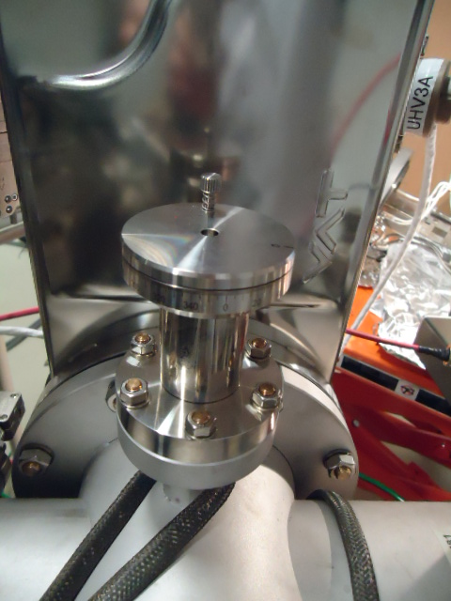
Cesium source manual Y position, adjustment.

- Set L3 back to 0.
- Centering in L4 without apertures (D0=D4=3000)
- Verify that L3 is set to 0. With beam On, bring the primary beam to the center of the FA using Beam Pos X & Y, and focus the beam at best using L4 and stigmators.
- With Beam On, adjust DP 4 X & Y deflectors to center the beam while wobbling L4. The values of DP 4 deflectors are in general close to zero.
- Adjusting the position of the D4 apertures
- Set D4=750µm. Verify that L3 is set to 0, and D0=3000.
- With Beam On, adjust D4 X & Y aperture position to center the beam while wobbling L4. Valid the D4 aperture preset.
- Repeat the same for all D4 apertures.
- Set D4 back to 750µm.
Note: the D4 X position is usually similar for all diaphragms (low value typically < 1000 digits). Each aperture has a different D4 Y position. Consecutive diaphragms have a difference in the Y position of ~3600 digits.
- Adjusting the position of the D0 apertures
- Set D0=750µm, while keeping D4=750µm.
- With Beam off, adjust D0 X & Y aperture position to maximize the primary current. Valid the D0 aperture preset. A primary current similar to without D0 should be obtained.
- Repeat the same for all D0 apertures.
- Set D0 back to 750µm.
Note: the D0 X position is usually similar for all diaphragms (low value typically < 1000 digits). Each aperture has a different D0 Y position. Consecutive diaphragms have a difference in the Y position of ~3600 digits.
- Maximizing the transmission through the D0 aperture
- Set D4=3000µm (no aperture) and set D0=400µm.
- Set L3 to ~1110 digits (for Source HV=10 kV) for a correct reading of the primary current.
- Set L2 lens values to the tabulated value (L2~1960 digits for Source HV=10 kV).
- With Beam Off, maximize the primary current with DP 3a X & Y.
- Centering the beam between D0 and D4 apertures.
- With Beam On, bring the primary beam to the center of the FA using Beam Pos X & Y, and focus the beam using L4 and stigmators.
- With Beam On, adjust DP 4 X & Y deflectors (and not the aperture position) to center the beam while wobbling L4. Save the primary preset.

After this alignment, the aperture positions and deflector values are fixed for each range of primary current: High, Medium and Low, and should no longer be modified.

Contents ↑

